Project Report: ShopEZ – One-Stop Shop for Online Purchases

# TEAM ID: LTVIP2025TMID55709

1. **INTRODUCTION**
   1. **Project Overview**

ShopEZ is a user-friendly e-commerce web platform that allows users to browse, search, and purchase a variety of products online. The platform features a responsive design with real- time cart updates, secure user authentication, and an admin dashboard for inventory and order management.

* 1. **Purpose**

To provide a seamless and reliable online shopping experience where users can conveniently explore and buy products while ensuring scalability, performance, and data security.

# IDEATION PHASE

* 1. **Problem Statement**

Customers often find it difficult to navigate multiple online stores with inconsistent interfaces and features. Small vendors also struggle to showcase their products online.

* 1. **Empathy Map Canvas**
     + **Thinks**: “Is this website secure and easy to use?”
     + **Feels**: Confused by cluttered interfaces.
     + **Says**: “I want everything in one place!”
     + **Does**: Abandons cart if checkout is too long.
     + **Goal**: To create a smart, unified shopping experience.
  2. **Brainstorming Ideas**
     + Dynamic product catalog
     + Real-time cart and checkout system
     + Admin inventory management
     + Customer order tracking
     + Secure login and registration

# REQUIREMENT ANALYSIS

* 1. **Customer Journey Map**

1. Visit website
2. Sign up / Log in
3. Browse or search products
4. Add to cart and checkout
5. Make payment
6. Receive confirmation and track order
   1. **Requirements**
      * **Functional**:
        + User registration/login
        + Product catalog, search, filter
        + Add to cart & order checkout
        + Admin product and order management
      * **Non-Functional**:
        + Responsive design
        + Data encryption and secure authentication
        + Fast page loads under high traffic
   2. **Data Flow Diagram**

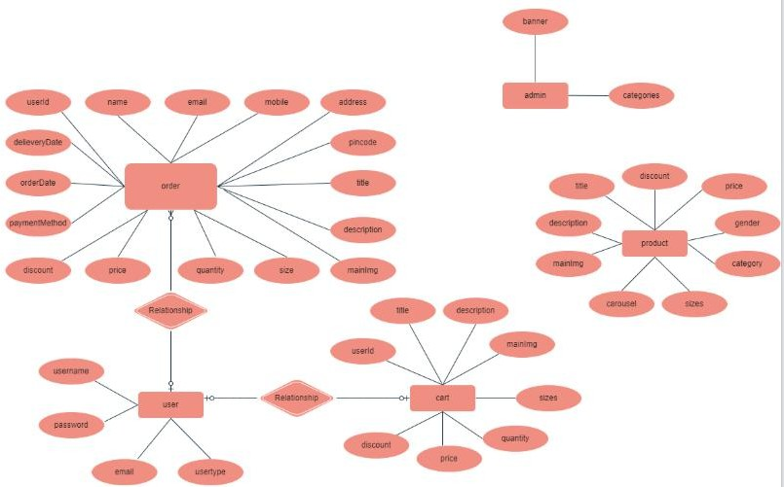

* 1. **Technology Stack**
     + **Frontend**: HTML, CSS, JavaScript, Bootstrap/React
     + **Backend**: Flask / Node.js
     + **Database**: MySQL / MongoDB
     + **Authentication**: JWT / bcrypt
     + **Deployment**: Heroku / Render / Vercel

# PROJECT DESIGN

* 1. **Problem-Solution Fit**

The online market needs scalable and reliable web stores. ShopEZ provides modern UI/UX, smart product filters, and admin tools to make e-commerce simple.

* 1. **Proposed Solution**

A modular, responsive web application with:

* + - User & admin portals
    - Searchable product listing
    - Shopping cart with checkout
    - Order history and tracking
  1. **Solution Architecture**

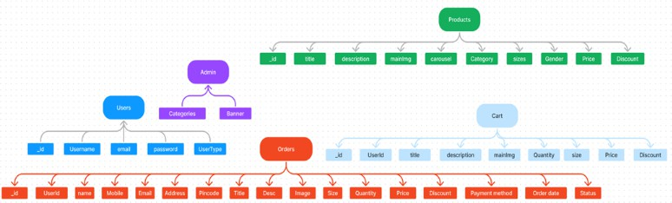

# PROJECT PLANNING & SCHEDULING

* 1. **Agile Plan (2 Sprints)**
     + **Sprint 1** (5 Days):
       - Build frontend templates (Home, Login, Product List)
       - Set up database schema
     + **Sprint 2** (5 Days):
       - Connect backend APIs
       - Implement cart, checkout, admin panel
       - Final testing & deployment
  2. **Velocity Chart**
     + Sprint 1: 10 Story Points (UI, DB setup)
     + Sprint 2: 14 Story Points (APIs, Admin tools, Testing)

# FUNCTIONAL AND PERFORMANCE TESTING

* 1. **Functional Testing**
     + Registration/Login
     + Product addition/removal in cart
     + Admin adding/deleting products
     + Order placing and tracking
  2. **Performance Metrics**

|  |  |  |  |
| --- | --- | --- | --- |
| **Endpoint** | **Avg Response Time** | **Max Concurrent Users** | **Error Rate** |
| GET /products | 0.40s | 100 | 0.3% |
| POST /checkout | 0.38s | 50 | 0.8% |
| Admin API | 0.45s | 30 | 0% |

* 1. **Tools Used**
     + Postman, JMeter, Locust

# RESULTS

* 1. **Output Screenshots**

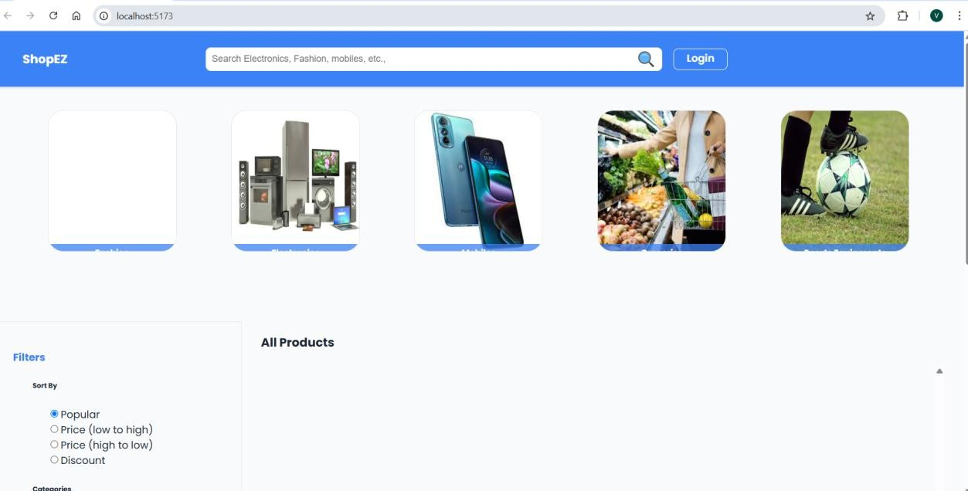

* **Registration**

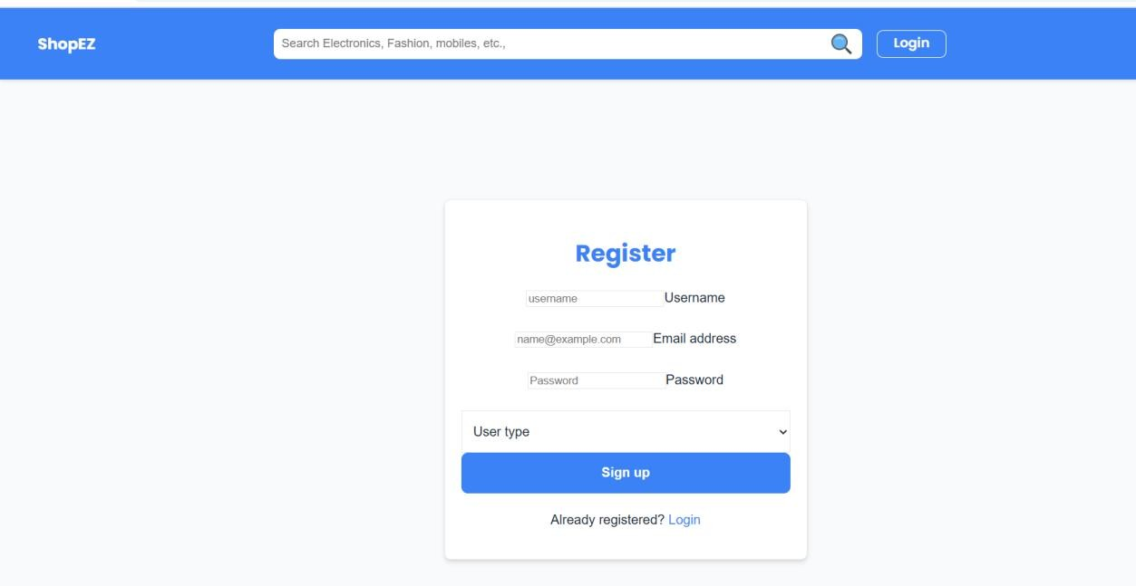

* **Dashboard**

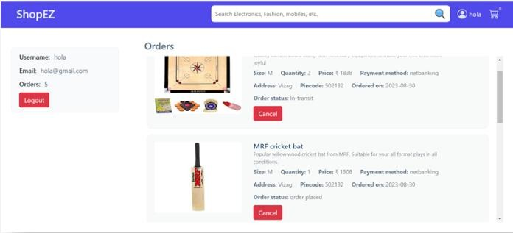

* **Cat**

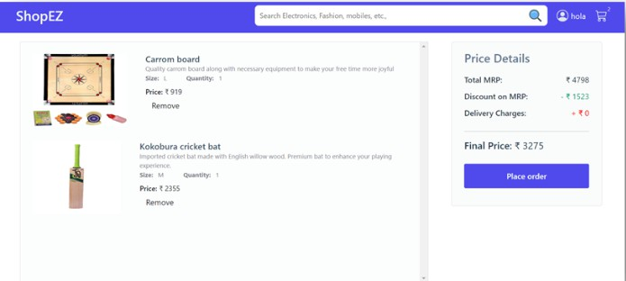

* **Admin dashboard**

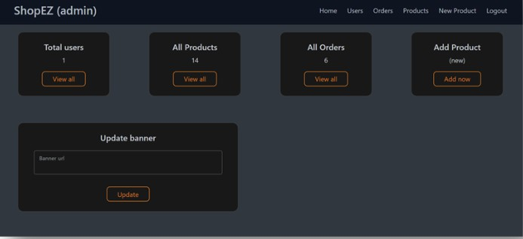

* **All Orders**

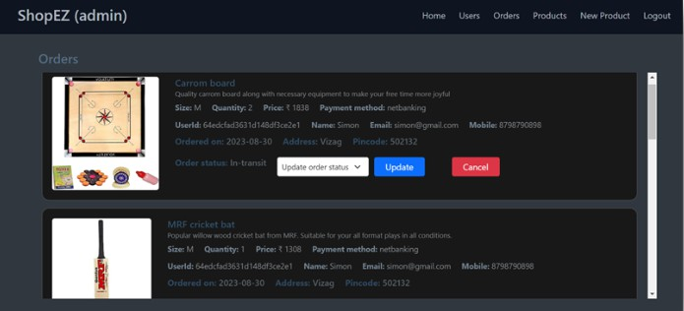

* **All Products**



* **New Product Page**

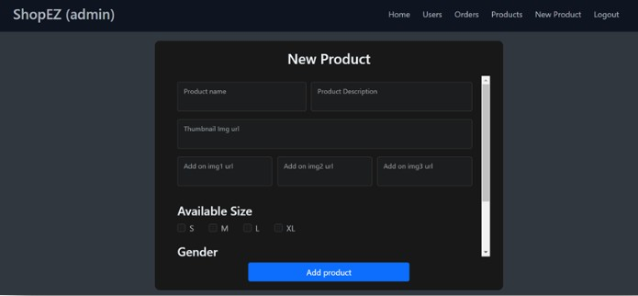

# ADVANTAGES & DISADVANTAGES

✅ **Advantages:**

* Easy navigation and minimal design
* Admin dashboard for control
* Scalable and modular code
* Secure authentication

❌ **Disadvantages:**

* No real-time inventory unless integrated with APIs
* Basic payment features

# CONCLUSION

ShopEZ successfully delivers a smooth e-commerce experience with key features like user login, product browsing, and checkout. The project lays the foundation for scaling into a larger commercial solution.

**Key Outcomes:**

* Mobile-friendly responsive site
* Secure backend with basic encryption
* Order lifecycle from cart to confirmation
* Modular frontend and backend separation

# FUTURE SCOPE

1. **Add Online Payment Integration**

(Razorpay, Stripe, PayPal)

1. **SMS/Email Alerts for Orders**
2. **Wishlist and Ratings Feature**
3. **Delivery Time Estimation Using Maps API**
4. **PWA / Mobile App Version**

# APPENDIX

* **GitHub Repo**: [Insert URL]
* **Demo Video Link**: [Insert Link]
* **Dataset/Inventory**: Sample JSON/MySQL Dump